3. Now try tuning the NN *on these two variables* using 5-fold CV. Use a grid of (1, 3, 5,

7, 9) nodes and (.001, .1, .5, 1, and 2) decay. Refit each combination of parameters 10

times to find the best sMSE for that combination.

(a) Compute the overall MSPE for each combination, and add 95% confidence intervals.

**Take square roots and report the results.**

(b) **Show relative root-MSPE boxplots of the five splits.**

(c) Use these results to **identify (i) the best combination, and (ii) other combinations**

**that seem to perform just as well.**

(d) Is further tuning necessary? **That is, is the best model (i) at a boundary**

**or (ii) quite different from neighbouring models?**



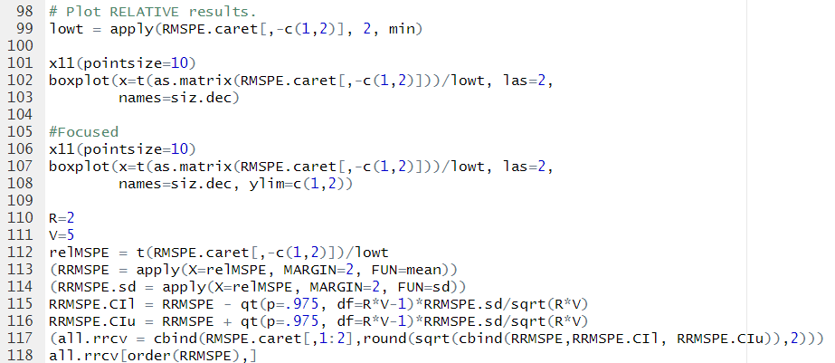

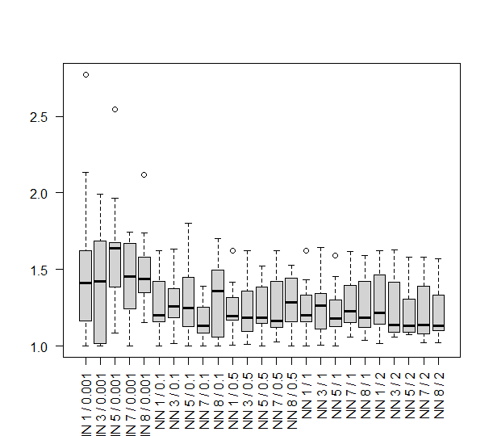

(c) Use these results to **identify (i) the best combination, and (ii) other combinations**

**that seem to perform just as well.**

It looks like a combination with 7 nodes and 0.1 shrinkage has the best result. However, other combinations for example, 5 nodes and 1 shrinkage, 1 node and 1 shrinkage also do well.

(d) Is further tuning necessary? **That is, is the best model (i) at a boundary**

**or (ii) quite different from neighbouring models?**

It’s quite similar with some other with other neighbouring models, so might need further tuning